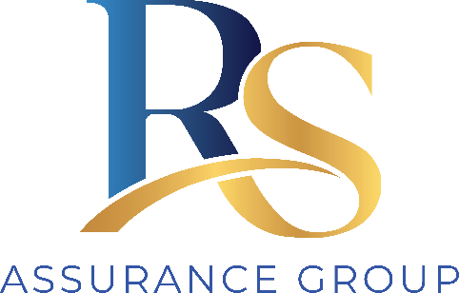
RS ASSURANCE GROUP
Governance
& Delegation Schedule

RS Assurance Group's organisational structure, key personnel, and who is authorised to make which decisions.
Document ID | DOC-GOV-001
Version | 1.0 (draft for completion)
Prepared by | Ainim Support Services
Prepared for | RS Assurance Group
Supports standards | 2.1 Governance; 2.7 Human resources
Approved by | [Name, Position]
Date | [DD/MM/YYYY]

1. Governance overview
RS Assurance Group is governed with clear accountability for quality, safety, compliance and finances. The person(s) with overall accountability ensure the organisation operates within the law, the NDIS Practice Standards and the Code of Conduct, and that participants are safe and well supported.

2. Organisational structure
Complete with RS Assurance Group's actual structure. Reporting lines flow from the governing person(s) down to workers.
Level | Role(s)
Governance / owner | [Director / owner name(s)]
Management | [Manager / coordinator roles]
Compliance & quality | [Compliance officer]
Support delivery | [Support workers / coordinators]
Administration | [Admin / scheduling]

3. Key personnel
The NDIS Commission requires key personnel to be identified and suitable. List them and confirm their screening.
Name | Role | Screening check | Suitability confirmed
 |  | ☐ Current | ☐ Yes
 |  | ☐ Current | ☐ Yes
 |  | ☐ Current | ☐ Yes

4. Delegation schedule
Records who is authorised to make which decisions. Where a decision exceeds a delegation, it is escalated to the next level.
Decision / action | Delegated to | Escalation / limit
Accepting a new participant / referral | [role] | [limit]
Signing a service agreement | [role] | [limit]
Approving expenditure | [role] | Above $[amount] → [role]
Reportable-incident notification to NDIS Commission | [role] | Owner: [role]
Managing a complaint | [role] | Unresolved → [role]
Managing a conflict of interest | [role] | [role]
Engaging / terminating a worker | [role] | [role]
Approving a policy or its review | [role] | —
Activating the Business Continuity Plan | [role] | —

5. Governance activities
- Business planning, financial oversight and performance monitoring occur on a defined cycle, with records kept.
- Insurances, registrations and financial viability are maintained and reviewed.
- Compliance with the Practice Standards is monitored, and this schedule is reviewed at least annually and when the structure changes.

Approved by — name and position Date

